image165.pngimage166.pngimage167.pngimage172.pngimage173.pngimage177.pngimage181.pngimage172.pngimage184.pngimage187.pngimage161.pngimage190.pngimage191.pngimage192.pngimage194.pngimage195.pngimage196.pngimage199.pngimage194.pngimage202.png



**Part 2**

**Promoting**

**Sayings of Wisdom**

**in the English Language Classroom**

image199.png image199.png

image203.png image203.png image203.png image203.png



**Section 1**

**Nurturing Hope**

**– Learning from Inspiring People**

**and their Experiences**

**Activity 1: Creative Writing Activities on**

**Biographies / Autobiographies**

##### Aim

This activity aims to introduce biographies/autobiographies of inspiring people to students and engage them in exploring the positive attributes of the selected people through creative writing tasks.

##### Values and Attitudes

Hope, perseverance, resilience, determination

##### Materials/Resources

A biography/an autobiography, graphic organisers

##### Procedures

1. Select an inspiring person and read a biography/an autobiography of the person with students.
2. Guide students to deconstruct the text using a graphic organiser (e.g. identify and summarise important accomplishments, famous quotes, significant moments or events of the person using a timeline or a sequence chart).
3. Highlight the positive attributes exhibited by the person.
4. Teach the text and language features (e.g. use of timelines, photos, captions, presentation of facts in chronological order) of a biography/an autobiography through modelling some text annotation strategies.
5. Instruct students to complete one of the creative tasks listed in the table on the next page. Invite students to present their work in class.



See tips for selecting a biography/an autobiography on p.12.

|  |  |
| --- | --- |
| **Designing an** infographic  **of an inspiring person**  Have students conduct research on an inspiring person of their choice from different sources (e.g. books, websites, magazine articles) and design a catchy infographic for the person.  Details that can be included in the infographic:   * his/her inspirational quote * important accomplishments of the person * things learnt from the person * ways to apply his/her good deeds/attitudes into the present-day life | **Creating a** fan page  **for an inspiring person**  Have students create a post on the social media platform to introduce an inspiring person.  Possible elements to include:   * fun facts * photos/videos * questions and answers about the person * a fan discussion board |
| **Writing a** blog entry **on**  **“A Day with ________”**  Ask students the following question **“If you were given a chance to spend a day with a person who inspires you, who would it be?”**. Have them write a blog entry. Pair up students who write on the same person and get them to refine their ideas together.  Possible ideas for students to write about:   * who to meet and why * where to go and what to do with him/her * what to say to him/her | **Writing a** thank-you letter **to an inspiring person**  Have students write a letter of gratitude to the inspiring person they have chosen.  Possible ideas for students to write about:   * reason for thanking him/her * how he/she has been an inspiration to the student * inspiring quotes or accomplishments of that person |
| **Creating a digital story about an inspiring person**  Have students select photos and make an audio recording to illustrate a motivational story of an inspiring figure.  Some guiding questions for students:   * What is the most remarkable event of this person? * Why do you find this person inspiring? * What have you learnt from this person? | **Writing a** podcast script  **to introduce an inspiring person**  Instruct students to write a five-minute script in groups or individually to introduce an inspiring person. Have a vote in class to choose the best three scripts. Get the three students/groups to record the scripts and upload their podcasts on the school website. |

##### 

Suggested Creative Writing Tasks



**Tips for selecting a biography/an autobiography**

To cater for learner diversity and make a learning task more engaging, give students the autonomy to explore great people in different fields (e.g. artists, athletes, astronauts, doctors, entrepreneurs, mathematicians, motivational speakers, musicians, philosophers, scientists, writers).

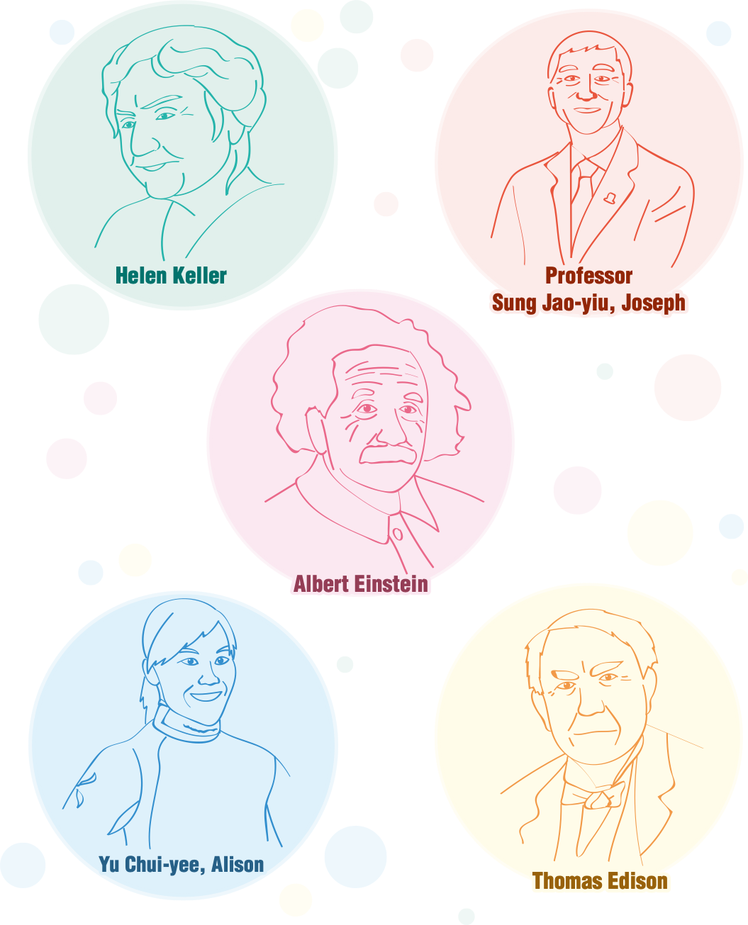

**Activity 2: Research on Famous Failures –**

**Learning from Stories about People**

**Who Embraced Failures with Grit**

##### Aim

This activity aims to discuss how failure can play a positive role in one’s journey to success. Through researching into the success stories of selected people, students learn how to perceive failure positively and persevere in the face of challenges.

##### Values and Attitudes

Hope, perseverance, resilience, determination, grit

##### Materials/Resources

Worksheet on “Learning From Famous Failures”

##### Procedures

1. Have students name some famous people who failed multiple times before reaching success. Ask if they know the people’s special journey to achieving their goals.
2. Share an article about a famous person who did not have a smooth run before achieving success. Discuss with students how he/she endured the failures and got back up. Examples: Thomas Edison, the Wright Brothers, Walt Disney, J.K. Rowling
3. Guide students to conduct research on other examples of “successful failures” by completing the worksheet on “Learning From Famous Failures” *(see pp.14 -15).*
4. Invite students to share and present their findings in class. Encourage students to give feedback (e.g. ask a follow-up question about the research findings) to their peers.
5. Have students discuss and reflect on how we should perceive failure and how failure can make us a better person *(see p.16)*. Ask each student to contribute three ideas and have them design a class poster on “Embracing Failures”.





Learning From Famous Failures

##### Think of a famous person and conduct research on him/her. Answer the following questions.

**1 What is the person famous for?**

**2 Research online and briefly describe his/her road to success.**

**3 Write about one or more failures that the person experienced.**

**4 How did the person overcome his/her failure(s)?**

**5 Can you identify any positive values and attitudes that the person exhibited in battling with the challenges?**

**6 What have you learnt from the person? How would you apply the thing(s) learnt to your life?**

##### How We Should Perceive Failure – Food for Thought

1. Failure means you have at least tried.
2. Failure helps you learn what doesn’t work.
3. Failure teaches you how to deal with disappointment.
4. Failure builds your character.
5. Failure helps you develop problem-solving skills and creativity.
6. Failure makes you strong and resilient.
7. Failure, as much as it hurts, is also a necessary part of life. It’s the pathway to our goals.
8. Failure allows you to reach new understandings and epiphanies on life, love and the people around you.
9. Every failure is a stepping stone to success.
10. Failure is the mother of success.

**Activity 3: The Power of Public Speaking –**

**Learning from Motivational Speeches**

##### Aim

This activity aims to introduce students to inspiring messages about life through motivational speeches. By appreciating the words of wisdom, students will be enlightened by the uplifting messages, and learn about the art of persuasive writing.

##### Values and Attitudes

Hope, perseverance, grit, kindness

##### Materials/Resources

Videos and transcripts of motivational speeches

##### Procedures

1. Select a video of a speech which conveys positive values and attitudes *(see suggestions on p.18)*. Get students to listen for the main ideas and identify the persuasive techniques used in the speech. Prepare a gap-filling worksheet for students to fill in the key words while they are listening to the speech.
2. After viewing the video, analyse the messages with students using the suggested reflective questions *(see p.18)*.
3. Distribute the transcript of the speech to students and guide them to identify the figurative language used in the speech.
4. Have students write their own motivational speeches on one of the following quotes. Encourage them to research the topic as thoroughly as possible by reading relevant materials and incorporate the figurative language learnt in their speeches.

image235.pngimage235.png“Learn from yesterday, live for today, hope for tomorrow.” (Albert Einstein) “Hope sees the invisible, feels the intangible, and achieves the impossible.” (Helen Keller)

image235.pngimage235.png“Cleverness is a gift. Kindness is a choice.” (Jeff Bezos) “Kindness is the language which the deaf can hear

and the blind can see.” (Mark Twain)

1. Invite students to deliver their motivational speeches in class or at school assemblies.



See tips for teaching figurative language on p.18.

##### Suggested Reflective Questions

image235.pngWhat have you learnt from the speech?

image235.pngimage235.pngWhat is the most impressive part of the speech? Which line has inspired you the most? Why?

image235.pngimage235.pngShare one important message you have learnt from the speech. How has the speech encouraged/motivated you?

image235.pngHow does the speech relate to your everyday life?

image235.pngimage235.pngIf you could ask the speaker a question, what would it be and why? To whom would you recommend the speech and why?

##### Suggested Speeches

|  |  |
| --- | --- |
| Connecting the Dots : Stay Hungry, Stay Foolish | Steve Jobs |
| Life without Limbs | Nick Vujicic |
| Fall Forward | Denzel Washington |
| You Will Prevail | Sundar Pichai |
| Grit: The Power of Passion and Perseverance | Angela Ducksworth |
| What Will You Be? | Jeff Bezos |



**Tips for teaching figurative language**

To analyse a speech, teachers may guide students to annotate the examples of figurative language used in a speech. The annotations that act as visual cues help students better understand the different language features of a compelling speech. The table below shows some common types of figurative language.

|  |  |  |
| --- | --- | --- |
| Alliteration | Allusion | Hyperbole |
| Idiom | Irony | Metaphor |
| Parallelism | Personification | Pun |
| Repetition | Rule of three | Simile |

**Activity 4: “What Happens Next?” – Predicting the**

**Storyline of Inspirational Short Animations**

##### Aim

This activity aims to enlighten students about adopting a positive attitude and different perspectives in the face of uncertainties and adversities. Through watching a short animation clip, students learn how to make predictions of a story and identify the positive messages conveyed.

##### Values and Attitudes

Resilience, empathy, staying positive and optimistic, perseverance

##### Materials/Resources

Inspirational short animations

##### Procedures

1. Select and play an inspirational short animation *(see suggestions on p.20)* for the first time.
2. Pause the video at specific times and engage students in making predictions of the plot at different stages *(see suggested activities on p.21)*.
3. Have students identify the unpleasant experience or challenges (e.g. a disability, a

challenging task, an unfortunate circumstance in the family) faced by the characters in the short animation.

1. Discuss how the characters handle/overcome the adversities. Ask students to put

themselves in the shoes of the characters and share what they would do and how they would feel if they faced similar challenges.

1. Play the short animation multiple times as necessary to analyse the fictional elements

(e.g. themes, setting) and cinematic techniques (e.g. camera shots, background music).

1. Conclude the lesson by eliciting from students the positive messages learnt from the

short animation. Get them to reflect on how they can apply those positive values and attitudes in the daily life.

##### Suggested Short Animations

|  |  |  |
| --- | --- | --- |
| Name of Animation | Positive Values and Attitudes | Synopsis |
| Hair Love | Hope, love, perseverance | Awarded the Best Animated Short Film in the Academy Awards in 2019, Hair Love tells a heart-warming story of an African American father learning to do his daughter’s hair for the first time for a special occasion. |
| The Present | Empathy, hope, love | A boy receives a present from his mom – a puppy with three legs. Originally focusing on playing his video games, the boy, who is also lame, is then moved by the acts of the puppy. |
| Ormie the Pig Wants a Cookie | Perseverance, determination, grit | The short animation captures Ormie’s quest for the jar of cookies placed at the top of a refrigerator. He tries multiple ways to get them but to no avail. Ormie persists and to him, each disappointment is a more elaborate attempt to achieve his goal. |
| My Shoes | Empathy, gratitude,  care for others | A lonely homeless boy in ragged clothes and worn-out shoes makes a wish about switching his shoes with another boy sitting on a bench with a brand new pair of sneakers. What has the boy learnt from the swap? It is a story with a twist which teaches us about gratitude and empathy. |

##### Suggested SOWIT Videos

|  |  |  |
| --- | --- | --- |
| Name of Video | Positive Values and Attitudes | Link to SOWIT Videos |
| Every cloud has a silver lining | Hope, optimism | image264.png  https://[www.edb.gov.hk/sowit](http://www.edb.gov.hk/sowit) |
| There is light at the end of the tunnel | Hope, optimism |
| Gratitude is the sign of noble souls | Empathy, gratitude |
| All roads lead to Rome | Hope, optimism |

##### Suggested Activities for Making Predictions

**Show pictures of a few scenes from the short animation before playing the video. Elicit from students their predictions about the theme, setting, plot and characters of the story.**

**Introduce sentence stems (e.g. “I know ______, so I predict ______.”, “I think ______ will happen as ______.”, “I predict that ______ because of ______.”) for students to make and justify their predictions.**

**Pause at an appropriate stage in the plot development and get students to exchange views about the development of the story (e.g. what a character will do, how a character will react, how a situation will turn out).**

**Have students illustrate the ending of the story based on the plot development. Get them to present their drawing and see whose prediction best matches the original story.**

**Towards the end of the story, get students to compare their predictions against the actual events of the story.**

**Distribute “YES” and “NO” signs to students. Prepare statements which describe the development of the story at different stages. Pause the animation at suitable intervals and get students to show whether they agree or disagree with the statements. Invite them to justify their views.**

**Activity 5: Looking up to Remarkable Athletes**

##### Aim

This activity aims to develop students’ self-learning capabilities and let them discover the positive attributes of successful athletes through conducting a research project.

##### Values and Attitudes

Hope, determination, learning from failure, perseverance

##### Materials/Resources

Videos of interviews of Olympic medalists

(e.g. Siobhan Bernadette Haughey, Cheung Ka-long, Yu Chui-yee)

##### Procedures

1. Have students select an athlete whom they are interested in (e.g. an Olympic medalist, a Paralympian, a Hong Kong young athlete, a football player, a basketball player).
2. Instruct students to conduct research on the athlete using the template on p.23.
3. Have students think of creative ways to present their findings (e.g. create a montage/digital story, design a game/an infographic/an e-book, write a shape poem, make a 3D visual display).
4. Organise an activity day/exhibition for students to showcase their work. Set up different
5. booths/counters categorised by different themes (e.g. positive values and attitudes, types of sports, types of games/activities).
6. Assign students to be the guide/presenter of their own booth/counter to introduce the
7. athlete and the activity they have designed.
8. Arrange visits by different classes and teachers. Get everyone to vote for their favourites (e.g. “The Most Artistic Booth”, “The Best Guide”, “The Most Creative Booth Activity”).

**A Research Project on**

Photo of the athlete

##### Background

Name:

Age:

Sports:

Events participated:

Achievement:

Good qualities of the athlete:

Things to learn from the athlete:



**Activity 6: Person of the Year**

##### Aim

This activity aims to provide opportunities for students to appreciate the positive traits of people through writing a feature article on “Person of the Year”.

**PERSON OF THE YEAR**

##### Values and Attitudes

Respect, appreciation, gratitude

##### Materials/Resources

A template of “Person of the Year”

##### Procedures

1. Introduce to students what a “Person of the Year” is. Show examples of interviews and articles about “Person of the Year” or “Kid of the Year” to elicit their interest in the topic.
2. Brainstorm with students the qualities of a great person.
3. Have students select their own “Person of the Year”. Encourage them to explore people in different fields.
4. Guide students to write a feature article to introduce the selected “Person of the Year”.

Possible details to be included:

image235.pngimage235.pngWho? – A brief introduction of the person Where? – Where is the person from?

image235.pngimage278.png What? – Important thing(s) that the person did How? – How has the person inspired you?

image235.png Why? – Why should we learn from this person?

1. Compile an anthology of students’ work showcasing the great people who are dear to their hearts.



The “Person of the Year” doesn’t have to be a celebrity. It could be our parents, siblings, teachers, friends or a stranger who has done a good deed!

**Activity 7: Exploring Positive Values and Attitudes**

**through Song Appreciation**

##### Aim



This activity aims to develop students’ listening skills through appreciating songs and lyrics with positive vibes.

##### Values and Attitudes

Hope, love, courage, kindness, perseverance

##### Materials/Resources

Songs conveying positive values and attitudes

##### Procedures

1. Play a song which conveys meaningful messages on positive values and attitudes (e.g. perseverance, hope, courage, kindness). Analyse the lyrics and messages of the songs.
2. Make use of different games and activities to engage students in learning more about

the song.

Suggestions:

* Lyric challenge: Change some of the lyrics of the song. Get students to first underline or circle words that they believe are incorrect. Next, play the song and get them to correct the words by themselves and then compare their lyrics with a partner.
* Scrambled lyrics: Prepare strips of lyrics. Give each group of students a set of strips and have them put them in order when they listen to the song.
* Visualising the song: Play the song and get students to discuss what it is about and the different scenes being depicted. Get them to create a storyboard to capture the essence of the song. Once students have finished drawing, have them compare their work with the other groups and discuss similarities or differences in their drawings.

1. Invite students to recommend a song on the following themes. Have them write a short description about the recommendation.

* Be grateful
* Cherish what we have
* Stay positive
* Stay optimistic

1. Organise a song dedication activity in collaboration with the school “Campus TV” or the “Broadcasting/Singing Club”. Post a list of songs on the school noticeboard and have students write a note to the person whom they want to dedicate the song to.

##### Examples of Songs and Suggested Activities

|  |  |  |
| --- | --- | --- |
|  | Song | Suggested Activity |
| 1 | Count on me  By Bruno Mars | Language focus: Using the first conditionals to express future possibilities, vocabulary items related to friendship  1. Design a gap-filling exercise based on the lyrics of the song, leaving the lines using the first conditionals blank.  2. Play the song.  3. Check the answers with the students and discuss the  form and function of the first conditionals.  4. Discuss and analyse the lyrics and message of the song.   * Do you have a friend like this? * Are you a friend like this? * Describe a friend who supported you.   5. Instruct students to highlight words/phrases related to friendship in the lyrics.  6. Have students write more lines using the first conditionals  to illustrate what they will do to support their friends.  7. Write a thank-you note to a friend or a loved one. |
| 2 | Resilient  (The Smile Video  Series)  By Katy Perry | Language focus: Metaphor  1. Bring a sponge to class. Squeeze it in front of students and then let go. Ask students what they can observe about the sponge. Introduce the word “resilient” to students by making reference to the metaphor of the ability to bounce back of a sponge.  2. Play the video of the song “Resilient”. Draw students’  attention to the life cycle of the tree in the video.  3. Invite students to share their ideas on what the life cycle of the tree represents. Discuss how the following visual images in the video are connected to real life:   * seed * leaves * tree trunk * flowers * cracks * concrete * sun and clouds * rain and thunder   4. Have students write a short reflection on a difficulty they have encountered and how they have faced it with resilience. |

**(Blank Page)**



**Section 2**

**Sowing Hope**

**– Leading a Hopeful Life and Being a Beacon of Hope**

**Activity 1: What is Your Bucket List?**

##### Aim

This activity aims to motivate students to stay hopeful, learn to set goals and strive for their goals in life by writing a bucket list.



##### Values and Attitudes

BUCKET LIST

Hope, perseverance, determination, hard work, love

##### Materials/Resources

Examples of a bucket list

##### Procedures

1. Start the lesson with a compelling question “If you had one day to live, what would you do?”

to elicit students’ interest in the topic.

1. Introduce to students what a bucket list is by showing them a related video/text/

a sample bucket list.

1. Have students reflect on what matters most to them and brainstorm what they would like

to achieve in life. Help them identify the positive values and attitudes (e.g. care for others,

integrity, love) reflected in the things dear to their hearts.

1. Highlight that a bucket list is not merely a list about personal desires, but also a list of

goals with an impact on one’s and other people’s lives in a positive way.

1. Have students write their own bucket list. Encourage them to set goals of different types (e.g. relationship, personal development, health, study, career) and for different time periods (e.g. short-term, long-term).
2. Conclude the lesson by reiterating that the focus of a bucket list is to remind people to

live a life with hopes and aspirations. Let students understand that making a bucket list allows us to reflect on our values and goals, and identify important milestones and experiences that we want to have in our lifetime.

1. Invite students to give updates about their bucket list regularly (e.g. every three

months, in each school term).



A bucket list may be modified into “A Summer Break Bucket List”, in which students set goals for things to accomplish during long holidays. Students may also compile “A Bucket List at XX School” to outline the goals to achieve before they graduate.

**Activity 2: Getting Inspired by Life Mottos**

##### Aim

This activity aims to boost students’ confidence in speaking through interviewing their teachers, parents and classmates for their life mottos. Learning about other people’s life mottos brings in different perspectives about life and enables students to stay positive.

##### Values and Attitudes

Hope, motivation, optimism

**LIFE**

##### Materials/Resources

Life motto cards, list of interview questions

**MOTTO**

##### Procedures

Sharing Life Mottos *(In-class Activity)*

1. Elicit from students their understanding about what a life motto is.
2. In pairs, have students match the mottos with the values in the Life Motto Worksheet *(see p.30)*.
3. After going over the answers with the students, have them share with a partner the values that are important to them. Get them research on and suggest some life mottos for the following scenarios:

image306.pngimage306.pngimage306.pngimage306.pngencouraging a friend who has a hard time adapting to a new school cheering up a friend who feels frustrated because of his/her exam results supporting a friend who has a problem in interpersonal relationships motivating a friend to do exercise and lead a healthy lifestyle

1. Invite students to explain their choices in class.
2. Have students write their life mottos on a “Life Motto Card” *(see p.31)* and display them on the class noticeboards.

Conducting an Interview about Life Mottos *(Outside Classroom Activity)*

1. Have students interview people about their life mottos.
2. Get them to prepare a list of interview questions for interviewing three different people (e.g. a classmate, a teacher, the principal, parents) and record the life mottos collected in a logbook *(see a sample page on p.32).*

Suggested Interview Questions

image307.png*What is your life motto?*

image307.pngimage308.png*How did you learn about this life motto? Why is the life motto important for you?*

image308.png*How has your life motto made an impact on your life?*

image308.png*If you are asked to share your life motto as an encouragement to somebody, who would that be? Why?*

1. Have students share in class one of the most inspiring life mottos they have collected and the things they have learnt from the interviews.



**Life Motto Worksheet**

Work with a partner. Match the following mottos with the personal values.

Mottos

Personal Values

|  |
| --- |
| (i) Being kind to others |
| (ii) Following your dreams |
| (iii) Persevering for personal growth |
| (iv) Taking risks |
| (v) Doing your best |
| (vi) Being content with what  you have |

|  |
| --- |
| A. Life is not a rehearsal. |
| B. Never stop learning. |
| C. Be the reason someone  smiles today. |
| D. Count your blessings. |
| E. If you can dream it, you can  achieve it. |
| F. Nothing ventured, nothing gained. |

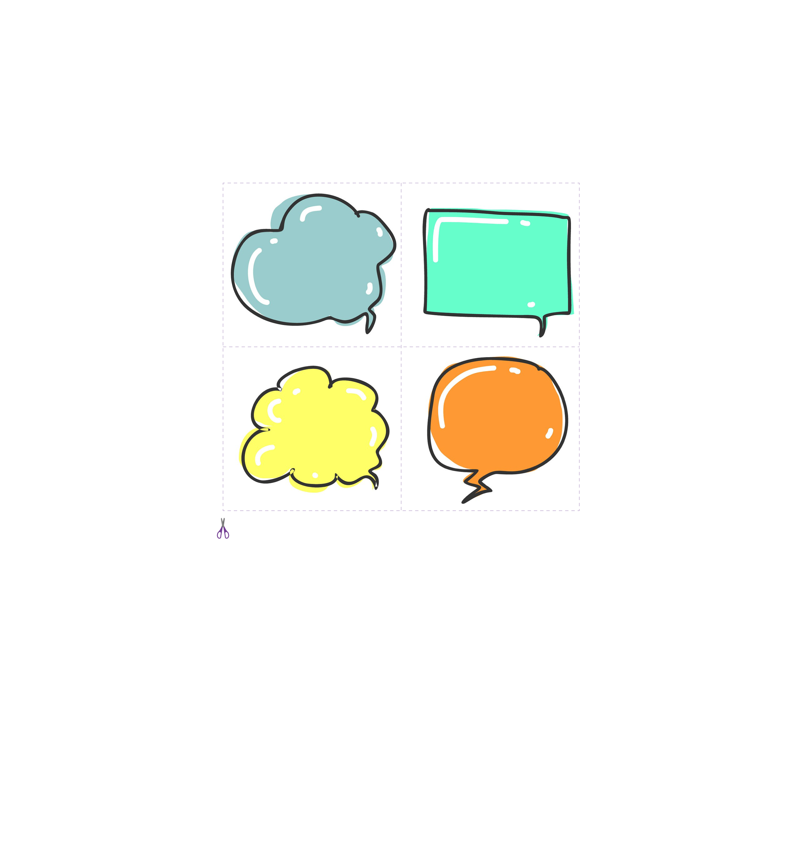**Life Motto Cards**



**Life Motto Logbook**

Date of interview: Interviewee:

##### Life motto of the interviewee

##### Things I have learnt from the interview

**Activity 3: Keeping a “Hope” Journal**

##### Aim

This activity aims to engage students in reflecting on things and people that bring them hope by keeping a “Hope” journal. Through writing about their goals and reflecting on the positive things and people around, students can learn what constitutes hope in life and be grateful.



##### Values and Attitudes

##### Hope, appreciating what we have, gratitude, optimism

##### Materials/Resources

##### A “Hope” Journal

##### Procedures

*A Personal “Hope” Journal*

1. Share a sample journal entry on a positive value.
2. Get students to prepare a notebook or a sketchbook. Let them decorate the cover of their journal in a way that represents them. Tell them that this is the space to dream, think and reflect.
3. Provide a list of prompts (*see p.34*) for students to choose from and allow them to write on

a topic of their choice. Get them to add an entry regularly and pair students up with a journal buddy to read and comment on each other’s entries.

*A Class “Hope” Journal*

1. Create a class “Hope” journal by starting the first page with the teacher’s expectations of what students would write and some dos and don’ts.
2. Devise a class roster for each student to take the class journal home and write an entry.
3. Students may add photos and drawings, share an article/a story which touches their heart or recommend a video/song which carries positive messages. Encourage students to be creative and invite their parents to contribute together.
4. Invite students to read and respond to their peers’ work by giving comments/drawing a

smiley/putting a sticker on the respective pages.

##### Prompts for a “Hope” Journal



##### Help a person by spreading hope to him/her. Record the experience.

##### Share an inspiring quote with a family member. Write an entry about the experience.

##### Say “thank you” to three people and express what you are thankful for.

Thank you

##### Collect 5 inspirational quotes and write them in the journal.

Collect a piece of news about hope. Share your views about it.

##### Write an acrostic poem by using the word “Hope”.

NEWS

##### Write a note of encouragement to your classmate.

##### Write down three things you appreciate about your friend/parent/ teacher.

##### Take a photo to show your understanding of a positive value. Write a short description about the photo.

**Give a compliment**

**to yourself. Write the compliment in the journal.**

##### Watch a video or an animation about hope. Share what it is about and what your classmates can learn from it.

**Recommend a song that conveys a positive message to your friend.**

**Activity 4: Interactive Speaking Activities on Hope**

##### Aim

This activity aims to get students to think and talk about hope with their peers. Their understanding and perspective about hope as well as their active listening skills will be enhanced through taking part in the activities.

##### Values and Attitudes

Hope, motivation

##### Materials/Resources

Strips of paper with questions on hope, group discussion record, peer feedback form

##### Procedures

Group Work

1. Design some questions related to hope. Print them on strips of paper.

Suggested Questions on Hope

影像

|  |
| --- |
| 1. What is hope? |
| 2. What are the benefits of having hope? |
| 3. What does a hopeful person look and sound like? |
| 4. How can we bring hope to other people? |
| 5. How can we stay hopeful in the face of adversity? |
| 6. How can we honour people who bring hope to us? |
| 7. Can you suggest a community or individuals that might benefit from hope? |
| 8. Is hope the same as desire? |

1. Conduct a group speaking activity using the cooperative learning activities below.

|  |  |  |
| --- | --- | --- |
| **Think-Pair-Share** | **Round Robin** | **Jigsaw** |
| Pose a question to the group and give each student two minutes to think about the question. Instruct students to discuss it with someone sitting next to them, and then share their ideas with the whole class. | Get students into groups of three to four. Ask them a question. Have students take turns to share their ideas with each other in their group. Ask students to come up with an answer for each question. | Arrange students to form “home groups” and “expert groups”. Give each group a question. Students research on the question and discuss their ideas with those having the same question (their “expert group”). Ask them to return to their “home group” to share the ideas. |
| **Numbered Heads Together**  Get students into groups and give each group a number. Ask students a question and have them discuss it with their group members. Call a number when time is up. Students with that number stand up and take turns sharing what they have discussed in their groups. | **Write Around** | **Tea Party** |
| Get students into groups of three to four. Give each group a question. Have students take turns writing their response to the question on a piece of paper. Give students an allotted time to write their responses. Ask students to pass the paper to the next group member, who then takes the time to read over what the other group member wrote and add to it, explain it further, or clarify what was written. Give each student the chance to respond to the question. | Help students to form two circles facing each other (one inner circle and one outer circle). Give students a question and ask them to discuss it with the student they are facing. Give students an allotted time to exchange their views on each question. Ask students in the outer circle to move towards one direction and exchange their views with a new partner after every move. |

1. As a wrap-up, get students to give comments to each other using the peer feedback form *(see p.38)*.

**Other Speaking Activities to Nurture Hope**

Public Speaking

Have students prepare a speech on a topic related to positive values and attitudes. Hold an in-class competition to select the representatives for inter-class or territory-wide public speaking contests.

Show and Tell

Have students select an object that represents hope to them. Get them to speak about the object for a set time limit and invite the rest of the class to ask questions.

##### Peer Feedback Form

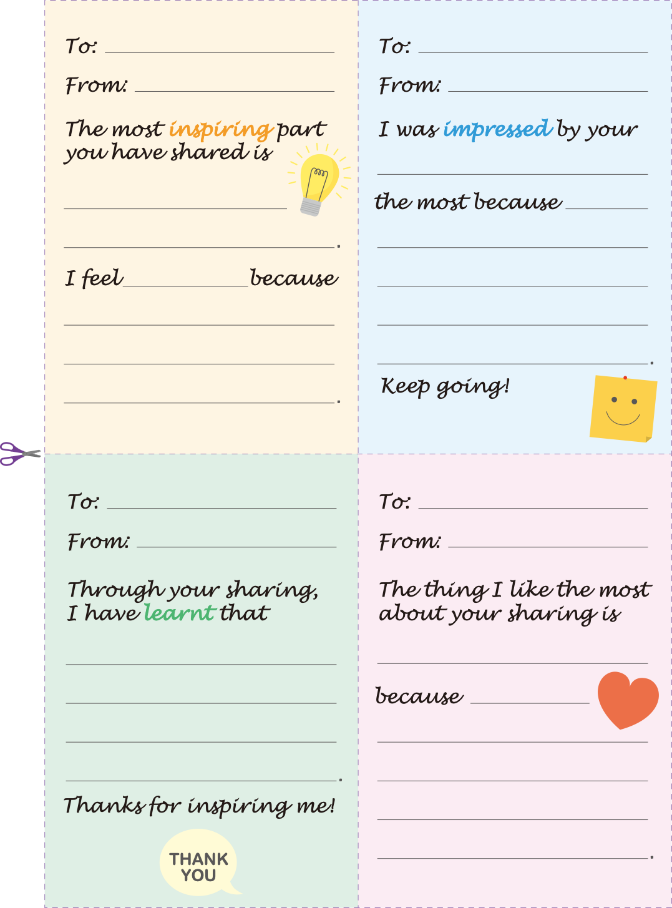

**Activity 5: “Let’s Walk the Talk” Proposal Writing**

**Competition**

##### Aim

This activity aims to encourage students to put their thoughts into actions and be a hope builder through joining a proposal writing competition. They make suggestions on ways to bring hope to a target group of their choice.

##### Values and Attitudes

Hope, empathy, care for others

##### Materials/Resources

A template for proposal writing

##### Procedures

1. Organise the “Let’s Walk the Talk” Proposal Writing Competition in school. If possible, engage the school management to support the competition financially so that winners of the competition will receive support from the school to put their proposals into practice.
2. In class, show students videos and/or articles about people or organisations around the

world that make a difference to their communities and bring hope to others. Highlight the importance of passion, determination, hard work and perseverance in being a change agent.

1. Ask students to research and select a charity/target group which they would like to

support. Explain that they are going to work on a persuasive project to solicit support from their classmates/parents/school.



See tips for selecting a charity/target group on p.40.

1. Encourage students to be empathetic and compassionate when identifying the needs of the target group and be creative and pragmatic when proposing measures for bringing hope to the group.
2. Provide a proposal template *(see p.41)* for students. Guide students to use the “SMART goals” framework to brainstorm ideas for their proposals.

|  |  |
| --- | --- |
| **Specific** | What exactly do I want to do to help the charity/target group? |
| **Measurable** | How will I measure the progress and outcomes? |
| **Attainable** | What skills/abilities are necessary to achieve the goals? |
| **Relevant** | Why is the goal important? |
| **Timely** | When do I plan to reach my goal? |

1. To prepare students for presenting their proposals, get them to introduce the proposal to and seek advice for improvement from at least two people (e.g. parents, teachers, the principal, friends).
2. Select the winners and invite them to present their proposals to the school management.

The table below provides some suggestions for who to help and how to help.

|  |  |  |  |
| --- | --- | --- | --- |
| **Who to help and**  **How to help** | Stop hunger | Support recycling projects | Help singleton elderly |
| Volunteer at  animal shelters | Donate food to food banks | Promote equality |
| Support non-profit organisations | Foster an animal in need | Clean up beaches and the countryside |
| Promote a healthy lifestyle | Donate blood | Support deprived children |

**Project Title**

Submitted by on

##### Background



Describe how this project came about, who is involved and the purpose.

##### Aims and Objectives



Describe what you would like to achieve.

##### Target Group



State the target group which you would like to bring hope to and how the target group will benefit from the project.

##### Proposed Activities



Describe the activities which you would organise.

##### Timeline



Propose a schedule for implementing the proposed activities.

##### Budget



State how much money you need to run the proposed activities.

##### Evaluation of Outcomes



Describe how you are going to evaluate the project and the success criteria.

###### Endorsement – We support the project!

|  |  |  |  |
| --- | --- | --- | --- |
| **Name** | **Signature** | **Suggestions for Improvement** | **Date** |
|  |  |  |  |
|  |  |  |  |

**Activity 6: Writing an Acrostic Poem/a Shape Poem on Hope**

##### Aim

This activity aims to unleash students’ creativity and enhance their knowledge about poetic devices for writing a poem on hope.

##### Values and Attitudes

Hope, positivity

##### Materials/Resources

A4 paper, colour pencils, tablet computers

##### Procedures

Writing an Acrostic Poem

1. Show examples of acrostic poems and get students to name some features of an acrostic poem (e.g. each line starts with a capital letter that spells out the poem's theme vertically).
2. Introduce what an acrostic poem is and analyse its poetic features with students.
3. Instruct students to write their own acrostic poem on the word “hope” or other positive values (e.g. empathy, respect for others). To cater for learner diversity, teachers may brainstorm with students some vocabulary items related to hope.
4. Add pictures or designs to make the poem look appealing.
5. Invite students to read aloud their poems and introduce the inspiration for their writing.
6. Have students design a bookmark for their acrostic poem.

Writing a Shape Poem

1. Revolving around the word “hope”, ask students to think of an object that has special associations for them (e.g. a star, a pair of wings, a heart shape).
2. Ask students to draw a sketch of the object.
3. Ask students to write down the words they associate with the object they have chosen. (e.g. Words associated with “hope”: future, optimistic, glimmer, cherish, love, grow, dream, joy, fly, aim, work hard, faith, wish, yearn, aspire, opportunity).
4. After compiling a list of 10-20 words, ask them to write six to ten short sentences incorporating some of their words.
5. Instruct students to organise their own sentences into a prose poem. Encourage them to edit what they have written.
6. On a piece of A4 paper, get students to draw the outline of the object they selected. Have students write their poem inside the shape of the object, where possible, using the shape creatively to fit the words.
7. Invite students to share their visual poems in class. Display the poems and get students to choose their favourite ones.

##### Examples of acrostic poems and shape poems on “Hope”

*Hope*

*Happiness Optimism Perseverance Enthusiasm*

*Hope*

*Holding on to all possibilities*

*Opting out of all negativities*

*Pouring out your thankful thoughts*

*Endeavouring to walk the talk*

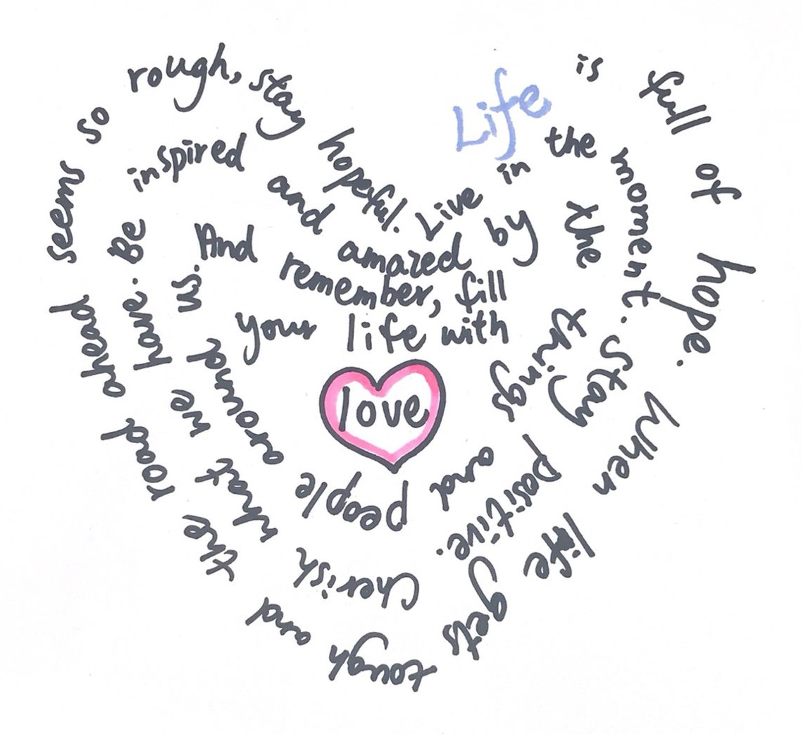



**HOPEFUL!**

**STAY**

When life gets tough and the road ahead seems so rough,

**Activity 7: Writing a Six-word Story on Hope**

##### Aim

This activity aims to enhance students’ creativity through writing a six-word story on hope.

##### Values and Attitudes

Hope, optimism, gratitude

##### Materials/Resources

Examples of six-word stories

##### Procedures

1. Introduce to students what a six-word story is by showing an example *(see examples on p.45)*

on the blackboard.

1. Ask students what comes to their mind when reading the examples. Let the class brainstorm for several minutes, encouraging them to share their interpretations of the words, and write their ideas on the blackboard.
2. Highlight the features of a six-word story.

image308.pngimage308.pngExamples: Brevity Imagination

image308.pngIt describes something powerful, expresses a feeling, or shares something intimate about one’s life.

image308.pngIt provides a movement of conflict, action and resolution that gives the sense of a complete story.

1. image308.pngHave students write a six-word story on hope using the following ideas: Create a storyline so that readers can use their imagination.

image308.pngThink about all the words related to the theme/topic. Use at least one verb to indicate

the key action in the story.

image308.pngSelect the words which can best present their message.

image308.pngGo for a twist or a contradiction. Say what the reader doesn’t expect or add some mystery.

image308.pngUse appropriate punctuation marks to help readers make sense of the words.

1. Hand out students’ six-word stories in class and get them to read a story written by their peers. Have students write their understanding and interpretation of the story on a piece of paper. Send the comments back to the writers so they can read and respond to the comments.
2. Discuss the writing process with the students.

image308.pngimage308.pngHow is a six-word story different from the stories students wrote in the past? How did they narrow the original story down to just six words?

image308.pngimage366.pngHow did they decide what matters (and how it matters) in the story? What are the key words that appear most frequently in the stories?

**Family, friends, laughter, love, sharing together.**

**The sun rises. Still breathing.**

**Warmth.**

*I’ll laugh about it one day.*

This is nothing.

I am fine.

45